
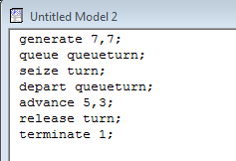
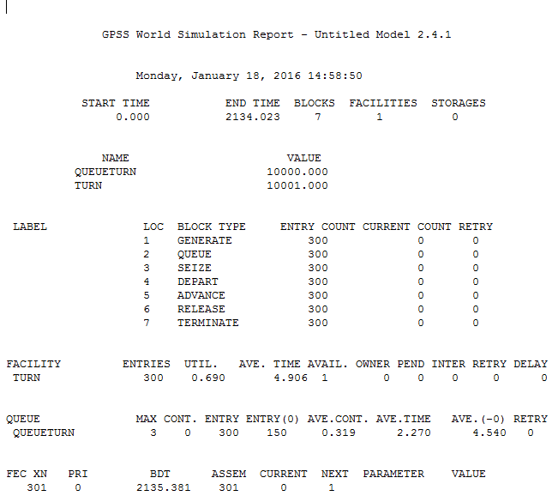
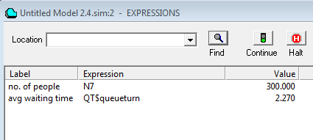
DEPARTMENT OF INFORMATION TECHNOLOGY Experiment No. 2
Semester | B.E. Semester VII – Information Technology
Subject | Computer Simulation and Modelling
Subject Professor In-charge | Prof. Indu Anoop
Laboratory | Lab 11B

Student Name | Mehal Chaudhari
Roll Number | 12101A0021
Grade and Subject Teacher’s Signature

Experiment Number | 2
Experiment Title | To create simulation for football stadium
Resources / Apparatus Required | Hardware:  Compatible Computer System | Software:  GPSS
Objectives  (Skill Set / Knowledge Tested / Imparted) | To Study GPSS systems
Theory  Output: | General Purpose Simulation System(GPSS) is adiscrete time simulation general-purpose programming language, where a simulation clock advances in discrete steps. A system is modelled as transactions enter the system and are passed from one service (represented by blocks) to another. This is particularly well-suited for problems such as given below;  Problem Statement:  Spectator arrives at a turnaround of the football stadium every 7+-7 seconds and it queue for admittance. The time to pass through is evenly distributed 5+-3 seconds. A model is required to determine the time taken by 300 people pass through turnstile. Create a simulation for 300 people.  Expression Window:
Conclusion | Thus, we have studied simulation for a football stadium using seven blocks and understood the expression window.

